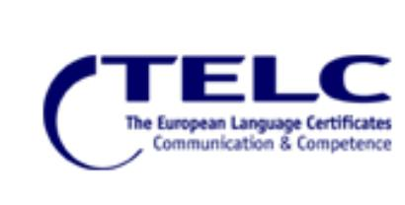
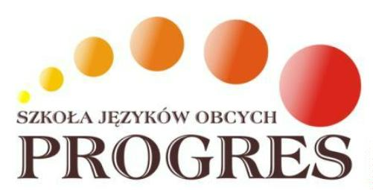

Release your tongue!

APPLICATION FORM FOR TELC EXAM
Name and surname:
Date of birth:
Place of birth:
Home address:
Phone number:
E-mail:

English/German/Spanish/French/Polish exam* (*strike out if not applicable)
level: |  | general / business/ dual level*  (*strike out if not applicable)

I hereby declare that:
I have read and understood the Rules and Regulations of the examinations conducted by Progres Language Center Jagóra i Nordyński Sp.j. and I agree to the conditions listed therein
I agree to the processing of my personal data for the administration of the exam following the Act of August 29, 1997, on the Protection of Personal Data (Dz.U. No.101 item 926 of 2002 consolidated text)
I declare that the data I have provided above are correct.

………………………………………………………
date and signature

Centrum Językowe PROGRES Jagóra i Nordyński Spółka Jawna, 91-408 Łódź, Pomorska 40.
+48 42 630 28 80, +48 600 010 189, www.progres.edu.pl

